**GENERAL INTEGRATED SCIENCE – UNIT 2**

**TASK 13 – Force, Energy and Motion test**

**WEIGHTING: 5 %**

**NAME: _________________________________**

**DATE: _________________________________ MARK: _____ / 50 = ______ %**

Important Information for Students

1. There are TWO sections in this test - Multiple Choice and Short Answer.
2. This is a closed-book assessment (no notes are allowed).
3. The time allowed to complete the test is 55 minutes.
4. Write your answers to the Multiple Choice section on the **separate** answer sheet provided.
5. Write your answers to the Short Answer section in space provided.

|  |  |  |
| --- | --- | --- |
| Sections | **Marks Allocation** | **Your Total** |
| **A - Multiple Choice** | 15 |  |
| **B - Short Answer** | 35 |  |
| **TOTAL** | **50** |  |

**Part A - Multiple Choice (15 marks)**

1. Which of the following is the best definition of energy?
2. Energy is what you need to run
3. Energy allows things to do work
4. Energy is a force to produce change
5. Energy makes objects change shape
6. What is the push or pull on an object that can cause it to accelerate called?
7. Mass
8. Force
9. Density
10. Speed
11. Which of the following is NOT a form of energy?
12. Mechanical
13. Electrical
14. Chemical
15. Newtons
16. Which of the following is a form of kinetic energy?
17. Sound
18. Elastic
19. Gravitational
20. Chemical
21. Unbalanced forces will cause an object to:
22. Move
23. Stay still
24. Always turn left
25. Increase in weight
26. Energy is measured in
27. Newtons
28. Watts
29. Joules
30. Calories
31. 457 Joules is equivalent to:
32. 457 000 kJ
33. 4 570 kJ
34. 0.457 kJ
35. 4.57 kJ
36. A student cut out a spiral from cardboard and set up the following apparatus.

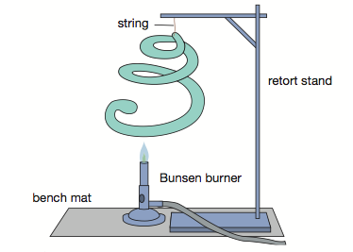

After the Bunsen burner had been lit, the snake started to spin around. The most likely explanation for this was

1. The potential energy stored in the snake was transformed into kinetic energy
2. There was a breeze in the room
3. Energy was being transferred to the snake from the retort stand
4. The heat energy from the flame was transformed into motion energy
5. Which of the following statements is NOT true?
6. Nuclear energy is classified as a type of potential energy
7. In an energy transfer some energy is always lost as heat
8. One source of energy can be converted into many different forms of energy
9. New energy is constantly being made
10. What is the sum of all the forces acting on an object called?
11. Gravity.
12. Reaction force.
13. Acceleration.
14. Net force.
15. In a tug of war, team A is pulling with a force of 100N and Team B with a force of 80N, what will happen?
16. Neither team will move.
17. Team A will go forwards with a force of 100N.
18. Team B will go backwards with a force of 20N.
19. Team B will go forwards with a force of 20N.
20. What do you multiply mass by to get weight?
21. Gravity.
22. Speed.
23. Density.
24. Energy.
25. Which of Sir Isaac Newtons’ Laws of Motion applies to the rocket while it is taking off?
26. First (the law of inertia).
27. Second (the greater the mass, the greater the force required to accelerate it).
28. Third (for every action there is an equal and opposite reaction).
29. Fourth (gravity may be defeated).

Question 14 and 15 refer to the information below.

Sophie conducted an experiment about rocket flight. She made 3 water-bottle rockets from an empty 2L fizzy-drink bottle, and each had 5 identical fins. She filled the rockets with different amounts of water and launched each rocket. Her results are found in the table below.

|  |  |  |
| --- | --- | --- |
| **Rocket** | **Amount of water (ml)** | **Maximum height (m)** |
| 1 | 200 | 8 |
| 2 | 400 | 23 |
| 3 | 800 | 37 |

1. The following are some of the control variables in this experiment:
2. bottle size, number of fins, amount of water
3. Fin size, number of fins, air pressure
4. bottle size, wind conditions, mass of bottle
5. number of fins, wind conditions, amount of water
6. A fair conclusion that can be made from the results of this experiment is that
7. increasing the number of fins will cause a water-bottle rocket to fly higher
8. a water-bottle rocket that contains less water will fly higher
9. a water-bottle rocket that contains more water will fly higher
10. the quantity of water contained in a water-bottle rocket has no effect on altitude reached

**Part B – Short Answer (35 marks)**

**Question One.**

1. Ashley and James were playing with a remote control car. They left the car to get a drink, and when they returned, they found the car at the same spot that they left it. Using **one** of Newton’s laws, explain why the car was found at the same spot. *(3 marks)*

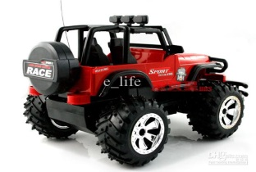_______________________________________________________________________________________________________________________________________________________________________________________________________________________________________________________________________________________________________________________________________________________________________________________________________________________________________________________________________________________________________________________

1. After playing with their car for a long time, Ashley noticed that the car was not responding well to the remote control. James replaced the old batteries with brand new ones and the toy began to work again.
2. State the type of energy found in the battery. _____________________ *(1 mark)*
3. State the energy changes that occur when the toy car is working normally. *(2 marks)*
4. Explain what is meant by the term wasted energy? *(1 mark)*

________________________________________________________________________________________________________________________________________________________________________

1. Imagine that the car battery contains 260 Joules of energy. If the toy car is only 35% efficient, calculate how much useful energy the car engine will produce? *(3 marks)*

**Question Two.**

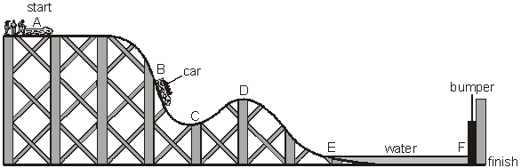The following diagram shows a rollercoaster ride. The car starts from A and travels to F, where it stops by hitting a bumper. At E, the car enters a trench filled with water. Use the letters to answer the questions.

1. At which **TWO** points does the car have **NO** kinetic energy? *(1 mark)*

__________________________________________________________________________________

1. At which point does the car have the **MOST** gravitational potential energy? *(1 mark)*

__________________________________________________________________________________

1. At which point does the car have **SOME** kinetic energy and the **LEAST** gravitational potential energy?

*(1 mark)*

__________________________________________________________________________________

1. The bumper at the end is designed to stop the passengers in the rollercoaster hurting themselves.
2. Which of Newton’s Laws is in action when the rollercoaster hits the bumper? *(1 mark)*

__________________________________________________________________________________

1. Justify why there needs to be the moat of water at the end of the ride rather than just the bumper using your knowledge of forces, types of energy and Newton’s Laws. *(2 marks)*

____________________________________________________________________________________________________________________________________________________________________________________________________________________________________________________________________________________________________________________________________________________

**Question Three.**

1. Explain how you would increase the gravitational potential energy of a book on the floor *(1 mark)*

____________________________________________________________________________________

____________________________________________________________________________________

1. Describe the difference between an energy transformation and an energy transfer *(2 marks)*

________________________________________________________________________________________________________________________________________________________________________________________________________________________________________________________________________________________________________________________________________

1. The sun shines on a farm, allowing wheat to grow. The wheat is used to make bread. An athlete eats the bread, and then goes for a run around an oval.

State which types of energy are found in the following objects.

1. Sun: _____________________________ & ___________________________ *(2 marks)*
2. *Athlete:* ___________________________ & __________________________ *(2 marks)*
3. Using this athlete as an example, explain the difference between a vector and a scalar quantity

*(2 marks)*

________________________________________________________________________________________________________________________________________________________________________________________________________________________________________________________________________________________________________________________________________

1. It is a hot day in Kalgoorlie, so you decide to go for a swim in a blow-up pool. Unfortunately, the water is too cold! To warm up the water, you have a choice of either adding a 10-litre bucket of water that is 50°C , or a 1-Litre bucket that is 100° C.

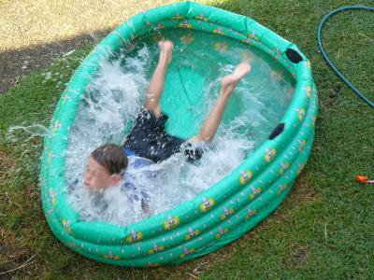

You can only add one of these buckets. Justify which one would warm up the water the most. *(2 marks)*

________________________________________________________________________________________________________________________________________________________________________________________________________________________________________________________________________________________________________________________________________

**Question Four**

Use the following formulas to help answer the following questions

**Speed = distance/time (v = d/s) Force = Mass x Acceleration (F = m.a)**

1. A dog takes 18 seconds to run around a semicircular track of length 72m.

What is the dogs speed? *(2 marks)*

1. A cyclist travels at a constant speed of 15m/s in a straight line for 15 seconds. She then travels in the same direction at 20m/s for another 15 seconds. Calculate her average speed for the whole 30 seconds.  *(2 marks)*
2. A skateboarder is accelerating at 2.5 m/s2. The skateboarder has a mass of 60kg and the board has a mass of 2kg. Calculate the size of the resultant force acting on the rider and the skateboard.  *(2 marks)*
3. The thrust from an outboard engine of a speed boat is 1000N. If the boat has a mass of 500kg and the friction force opposing the motion of the boat through the water is 200N, what is the acceleration of the speed boat. *(2 marks)*